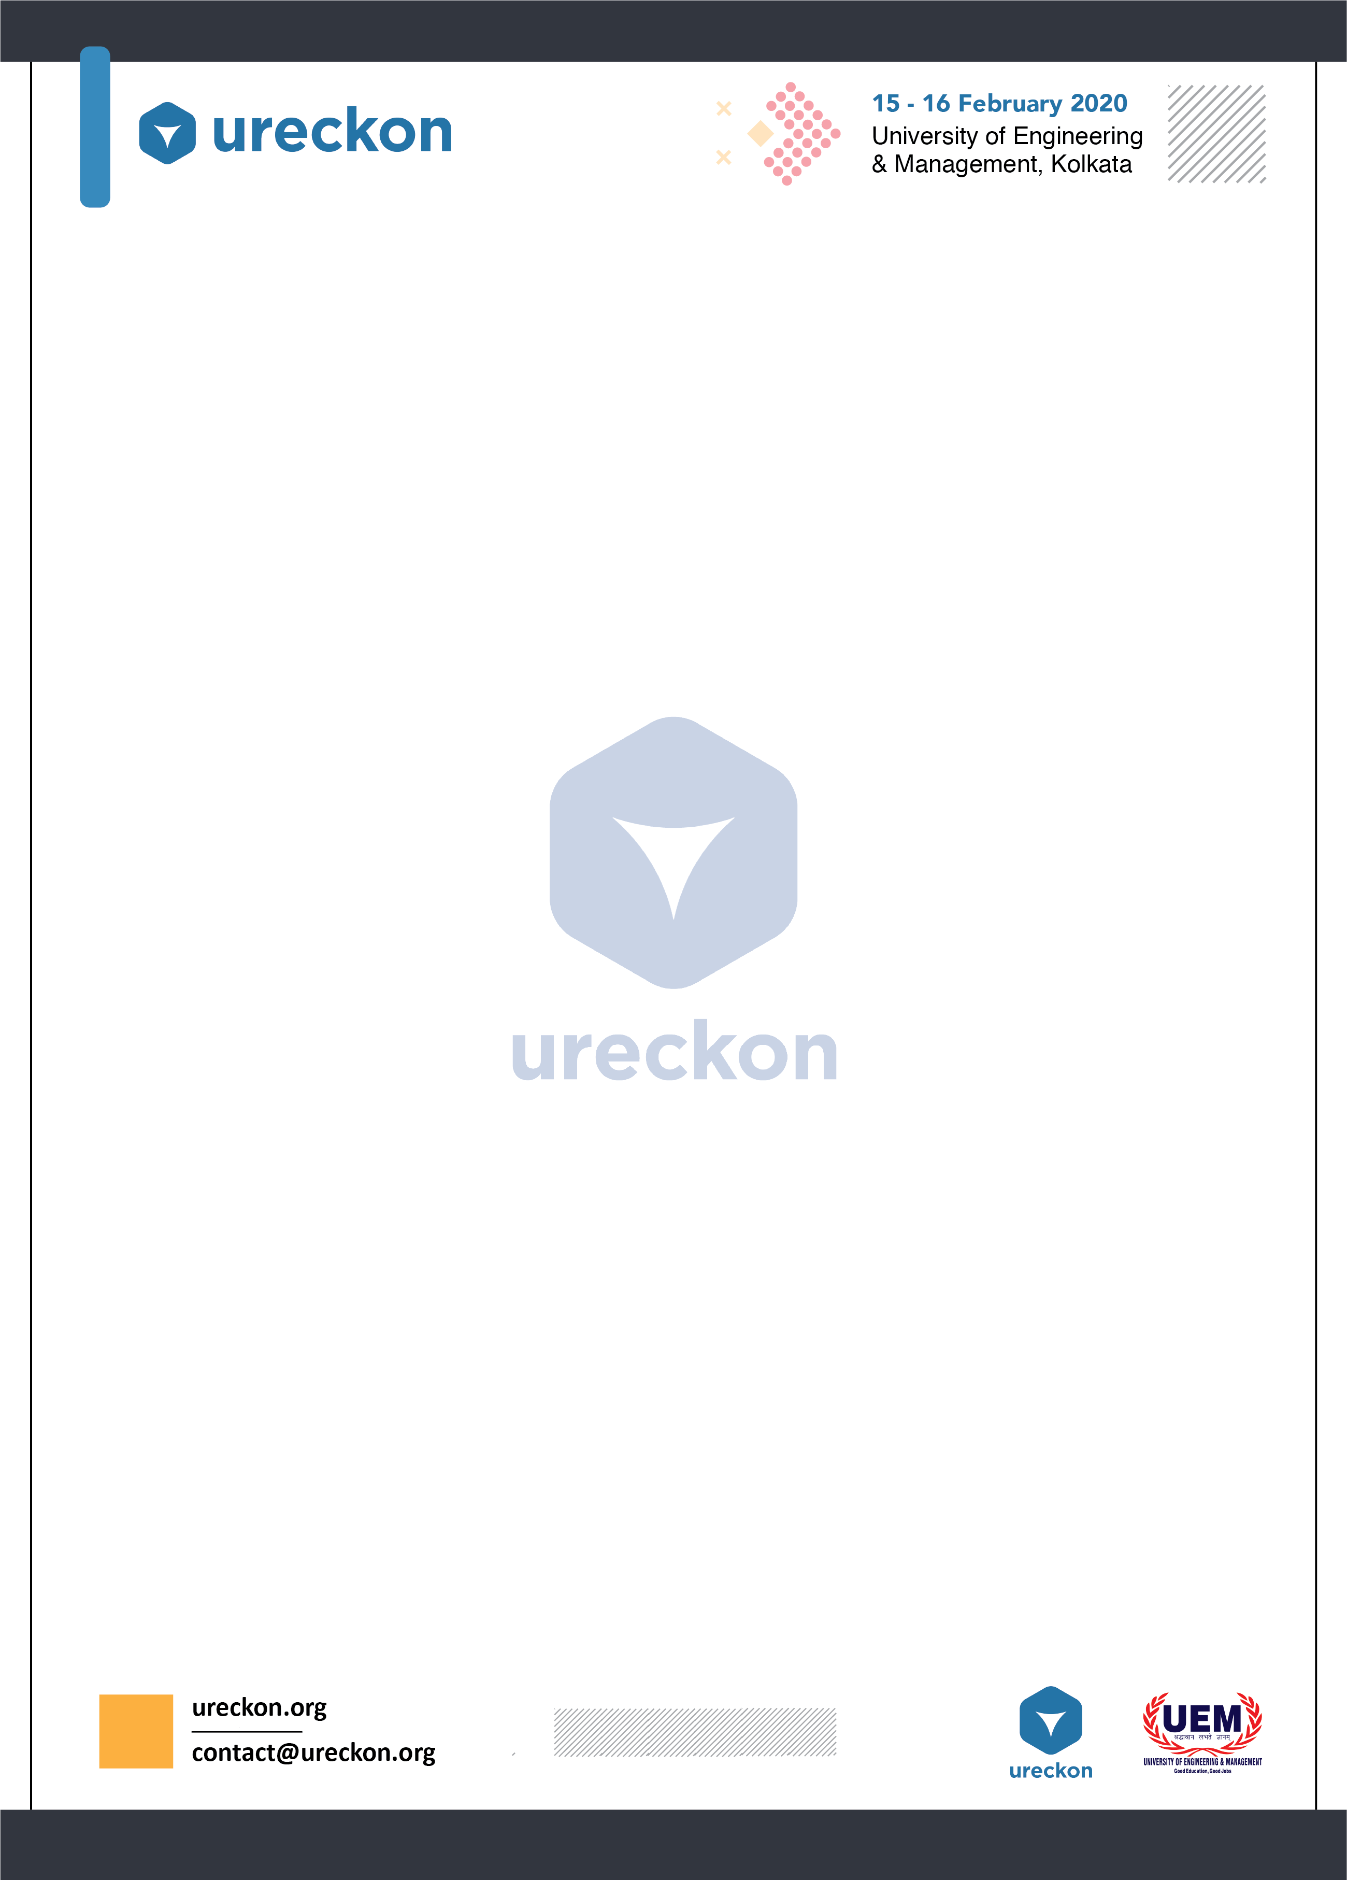

**INTRODUCTION**

Awareness is the best way to improve the society and environment and what can be a better way to make people aware than working models and posters depicting the creative minds of the upcoming generations coming up with innovative ideas and inventions to improve the society and environment we live in and trying to make people aware of their surroundings. Therefore we present ***BioteXpression***.

**WHAT IS BioteXpression?**

BioteXpression is an event in which participants have to display working models or posters related to any aspect of Biotechnology, Environmental Toxicity and Bio-remediation and explain how it works, ideas behind the working model or poster, future prospects of the idea and show its usefulness in the real world.

**RULES AND REGULATION**

1. All requirements(Poster, Laptops, Extension cords, batteries etc.) to be brought by the participants.
2. The model must be related to any aspect of Biotechnology, **Removal of Environmental Toxicity and Bio-remediation** is the main theme of this event.
3. If any team want to show a power point presentation for presenting their project they can but no projectors or any such gadgets will be provided. They have to use their laptops or any such media for that purpose.
4. Maximum team size - 4| Minimum team size - 2.
5. You are requested not to bring any harmful material and if you need one such for your project then inform us beforehand.

**JUDGEMENT CRITERIA**

* Idea and Creativity
* Usefulness
* Presentation

**NOTE:** Breaking any of the rules will make you liable to be punished by the management team present on the venue under their discretion.

**DATE :- 11th January, 2020**